Testing Reinforcement Learning through the 15-puzzle
Trevor Bekolay, 6796723

Abstract
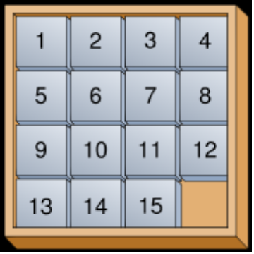
The intent of this paper is to examine the performance of reinforcement learning techniques using the domain of the 15-puzzle—a puzzle that contains a grid of numbered squares with one square missing, as pictured. Three different types of reinforcement learning techniques will be examined, one from each category of Dynamic Programming techniques, Monte Carlo method based techniques and Temporal Difference learning techniques.

Problem Definition
The 15-puzzle is often used in AI to test the feasibility of search based algorithms, as well as some neural networks and path-finding algorithms. This is because of the relative simplicity in defining and representing states and actions, which makes the problem easy to confine.
The Markov Decision Process (MDP) representation will be introduced and used from this point onwards.

Non-Learning Based Methods
Existing heuristical methods to solve 15-puzzles will be examined and tested to provide control results which the refinement learning techniques can be judged against.

Reinforcement Learning Techniques
Briefly introduces the three techniques that will be used.
- Dynamic Programming: Value Iteration
- Monte Carlo Method
- Temporal Difference Learning: Q-Learning

Testing and Results
Given the same finite number of defined problem states, test each learning technique to determine:
- How close does the algorithm eventually come to a near-optimal solution (based on the results determined from the non-learning based method), if it ever does?
- How efficient is each algorithm, with respect to processing time and memory usage?
- How many iterations before the algorithm performs significantly better than random?

Conclusion
Extrapolate from the results gleaned from testing, both comparing the three methods with each other, and the learning methods with the non-learning method.

